**Resources for Google Cybersecurity Certificate graduates**

Congratulations on completing the Google Cybersecurity Certificate! Your dedication has unlocked exclusive career-boosting resources and benefits. Access and share your badge of completion, receive personalized career guidance and interview practice, and take advantage of an exclusive discount on your CompTIA Security+ certification exam.

To claim these resources at no cost, simply access each using the same email address you used when registering for the certificate on Coursera. Please note that these benefits are only available to graduates who have completed all eight courses in the Google Cybersecurity Certificate program.

* **Complete the Google Cybersecurity Certificate (Done!)**
* **Claim your Google Cybersecurity Certificate badge and share it with your professional network**
  + Look for an email from Credly ([admin@credly.com](mailto:admin@credly.com)

• ) within one week of completing the certificate.

• Claim your badge on Credly’s Acclaim platform using the email address linked to your Coursera account. You’ll need to opt in to share your information for the purposes of badge issuing.

• Add the badge to your LinkedIn to highlight your skills by following the steps in this [Credly article](https://support.credly.com/hc/en-us/articles/360021221491-How-can-I-add-my-badge-to-my-LinkedIn-profile-and-share-to-my-feed-)

or [video tutorial](https://vimeo.com/725834127?embedded=true&source=vimeo_logo&owner=149323741)

* + .

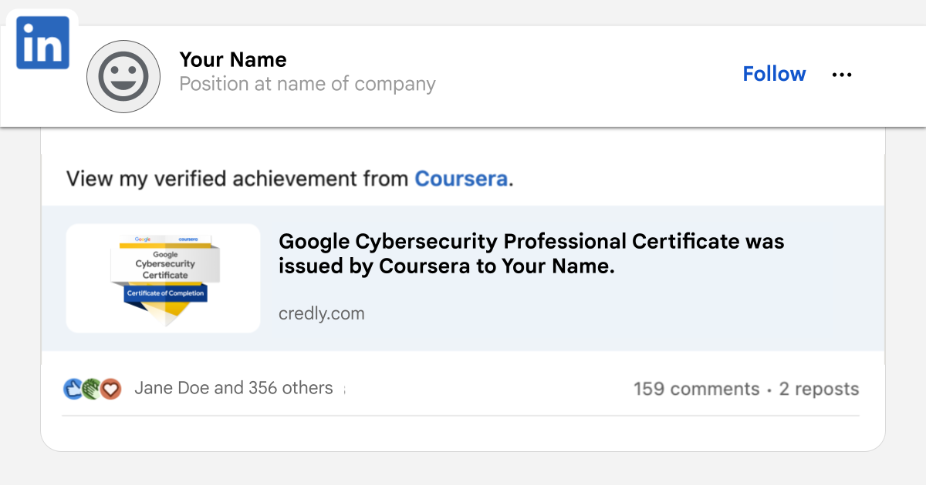

* **Showcase your new skills and expand your professional network:** Share your accomplishment on social media using our [sample posts and prompts](https://drive.google.com/file/d/1f8PpJyjmJS0A0_HA38VTI9kCLcRy1293/view)

• , and include #GrowwithGoogle for greater visibility.

• **Connect with a community of learners and discover new opportunities:** Follow Grow with Google on [LinkedIn](http://linkedin)

• to join a network of like-minded individuals and explore further learning possibilities.

• **Claim your 30% discount on the CompTIA Security+ Certification exam**, the industry-leading certification for cybersecurity roles. Use the code **cvcm30Security2025** at checkout for 30% off the cost of both [the exam](https://store.comptia.org/comptia-security-sy0-701-voucher/p/SEC-701-TSTV-23-C)

and [CertMaster practice](https://store.comptia.org/comptia-certmaster-practice-for-security-plus-individual-license/p/SEC-601-CMPI-20-C?utm_source=gwg&utm_medium=email&utm_campaign=cyber-comptia2__geo--US&utm_content=program-message)

• in the CompTIA store. When you pass the exam, you’ll also earn a new co-skilled badge to post on LinkedIn and other social networks!

• **Get no-cost interview prep, coaching, and resume support (US graduates only).** Google is giving certificate graduates like you free access to career support from [CareerCircle](https://www.careercircle.com/campaign/coursera)

• including a resume builder and interview preparation resources to help you land your next job. Plus, you’ll get access to free 1-on-1 career coaching and thousands of job postings from top employers. You must be eligible to work in the U.S. to unlock this resource.

• **Improve your interview technique with** [**Interview Warmup**](https://grow.google/certificates/interview-warmup/)

• **.** Practice interviewing with Interview Warmup, a tool built by Google with certificate graduates in mind. Access cybersecurity-specific practice questions, transcripts of your responses, and automatic insights that help you grow your skills and confidence.

• **Access free interview practice and job search tips with** [**Big Interview**](https://googlecerts.biginterview.com/)

• **.** Get practice with mock interviews, job search tips, and customizable resume templates with Big Interview, available free for one year to Google Career Certificate graduates.

• **Explore career possibilities with** [**Career Dreamer**](https://grow.google/career-dreamer/)

• **.** Career Dreamer is an experimental tool that uses AI to help you uncover your skills and personalized career paths based on your unique experiences and interests. Career Dreamer can help you:

* Draft a professional story that showcases the value you bring to the workforce.
* Explore career paths that might align with your skills and interests.
* Take steps toward your career goals, like creating a cover letter or resume.

• **Learn to navigate your job search efficiently and confidently using AI.** All Google Career Certificates include an optional new course, Accelerate Your Job Search with AI. This course will guide you to use AI to create a job search plan, professional pitch, resume, and more. This optional course is listed next in your certificate program, and you can access it [here](https://www.coursera.org/learn/accelerate-your-job-search-with-ai)

• .

• **Inspire others by sharing your story**. Stories from successful graduates, like you, can encourage the next generation of learners to pursue their passions. In addition, your feedback helps us improve the certificate program. Fill out [this short survey](https://docs.google.com/forms/d/e/1FAIpQLSfPm4bP-xfyDKdHtZVZTOJa20oMquyUrEw90Ss4SZgdBYWA7A/viewform)

* to tell us about your journey.